Part 1 (all performed with 80% and 20% train test split, iteration of 10):
1.A accuracy (Naive Bayes, treat 0 as it is):
The average accuracy over 10 times: 0.7418301
2.B accuracy (Naive Bayes, treat 0 in certain columns as NA):
The average accuracy over 10 times: 0.7098039
3.D accuracy (SVM, treat 0 as it is):
The average accuracy over 10 times: 0.7300654

Part 1 Code:
1.A (1.B has similar code):
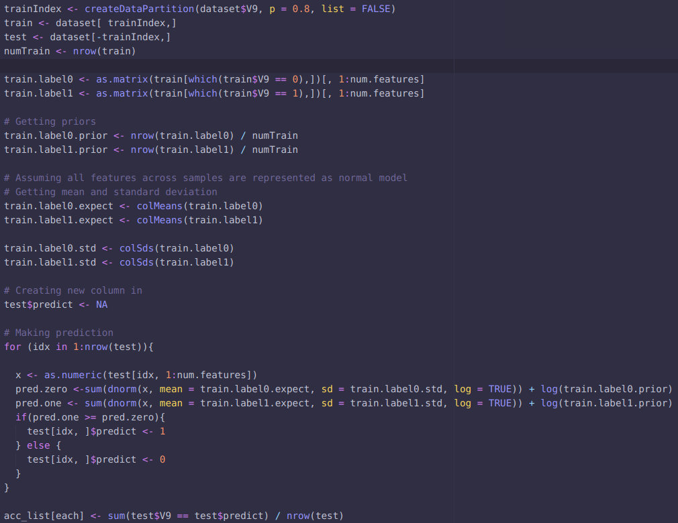
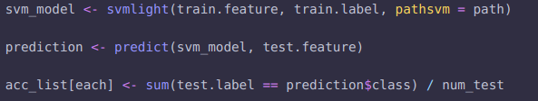
1.D (Train/test split is similar to 1.A and 1.B, omitted for the space):

Part 2 (Table & Submission Screenshot):

# | Method | Testing Accuracy (%)
1 | Gaussian + untouched | 55.75
2 | Gaussian + stretched | 81.70
3 | Bernoulli + untouched | 83.385
4 | Bernoulli + stretched | 75.57
5 | 10 trees + 4 depth + untouched | 75.12
6 | 10 trees + 4 depth + stretched | 75.675
7 | 10 trees + 16 depth + untouched | 96.12
8 | 10 trees + 16 depth + stretched | 96.595
9 | 30 trees + 4 depth + untouched | 76.995
10 | 30 trees + 4 depth + stretched | 78.255
11 | 30 trees + 16 depth + untouched | 97.175
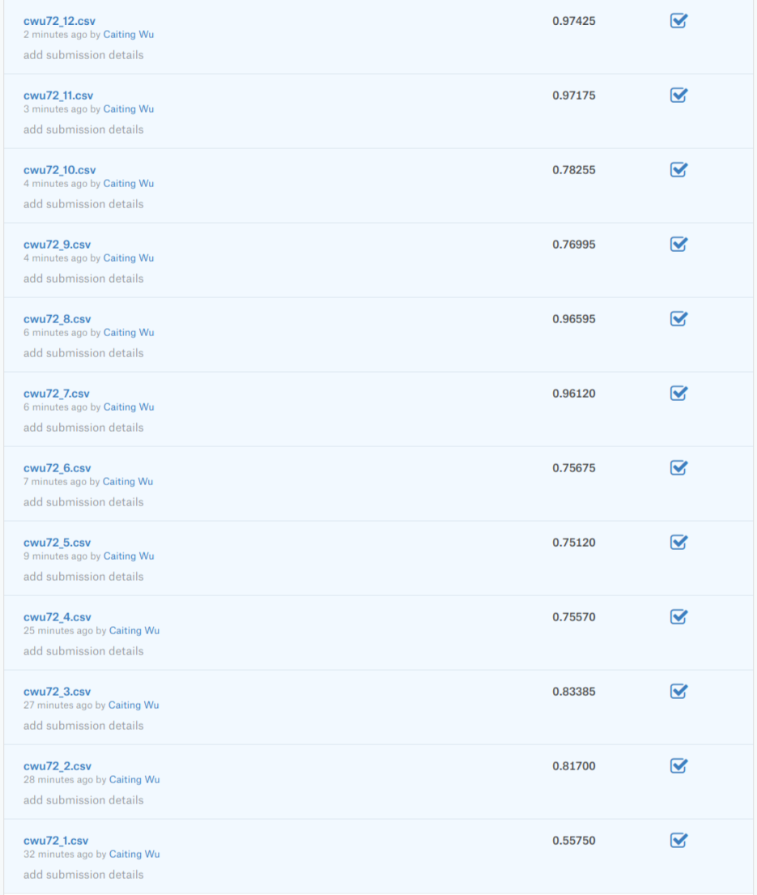  12 | 30 trees + 16 depth + stretched | 97.425

Part 2 (40 Pictures):

Gauss & untouch Gauss + stretch Bern + untouch Bern + stretch

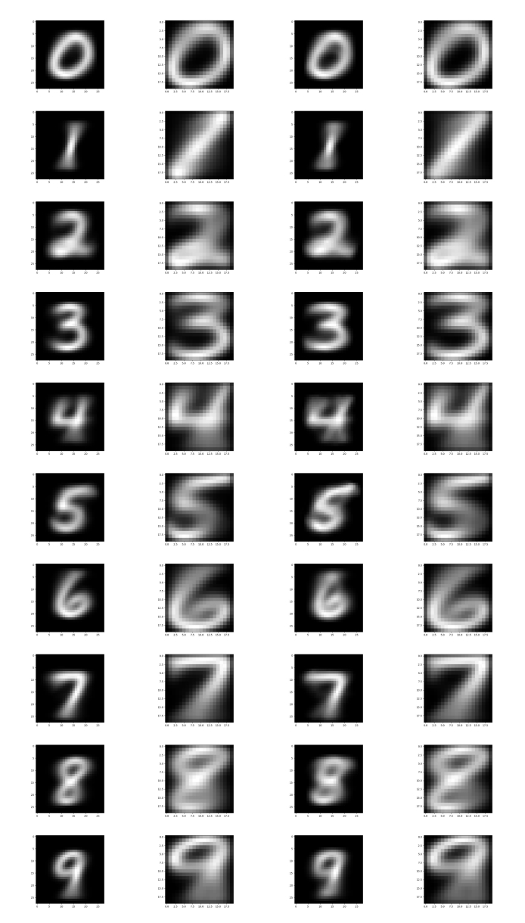

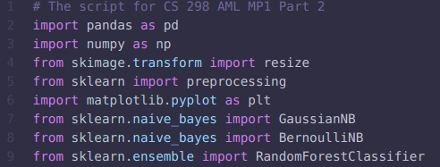
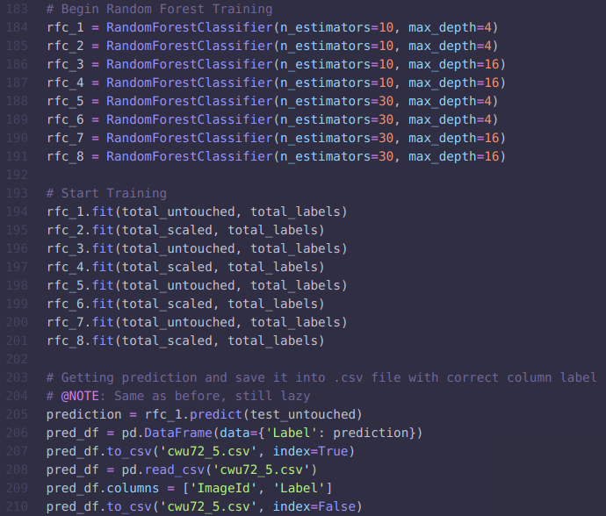
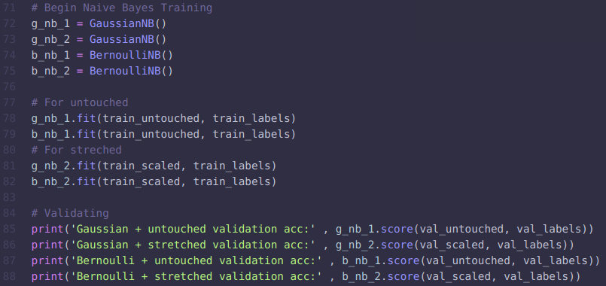
Part 2 (Codes):

